1 run......

Downloading: 100%

411/411 [00:00<00:00, 9.94kB/s]

Downloading: 100%

263M/263M [00:08<00:00, 26.0MB/s]

training 1 epoch...

141.5336377620697 seconds used......

1 training finished! average train loss: 0.9660731621162884

evaluating...

Confusion matrix, without normalization

[[ 30 0 85 9]

[ 17 2 36 16]

[ 45 1 805 14]

[ 4 0 15 74]]

Normalized confusion matrix

[[0.24193548 0. 0.68548387 0.07258065]

[0.23943662 0.02816901 0.50704225 0.22535211]

[0.05202312 0.00115607 0.93063584 0.01618497]

[0.04301075 0. 0.16129032 0.79569892]]

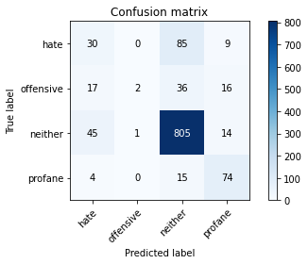

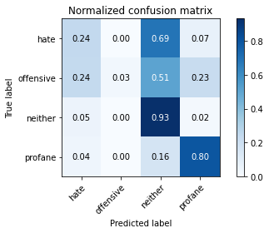

precision recall f1-score support

hate 0.31 0.24 0.27 124

offensive 0.67 0.03 0.05 71

neither 0.86 0.93 0.89 865

profane 0.65 0.80 0.72 93

accuracy 0.79 1153

macro avg 0.62 0.50 0.48 1153

weighted avg 0.77 0.79 0.76 1153

average eval_loss: 0.705581983101779, accuracy: 0.790112749349523

training 2 epoch...

140.69087052345276 seconds used......

2 training finished! average train loss: 0.8025501956304999

evaluating...

Confusion matrix, without normalization

[[ 47 1 62 14]

[ 19 2 24 26]

[ 85 1 753 26]

[ 5 0 8 80]]

Normalized confusion matrix

[[0.37903226 0.00806452 0.5 0.11290323]

[0.26760563 0.02816901 0.33802817 0.36619718]

[0.0982659 0.00115607 0.87052023 0.0300578 ]

[0.05376344 0. 0.08602151 0.86021505]]

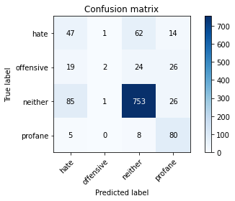

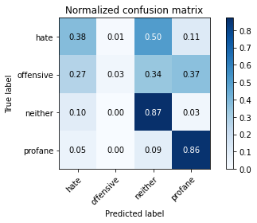

precision recall f1-score support

hate 0.30 0.38 0.34 124

offensive 0.50 0.03 0.05 71

neither 0.89 0.87 0.88 865

profane 0.55 0.86 0.67 93

accuracy 0.76 1153

macro avg 0.56 0.53 0.48 1153

weighted avg 0.77 0.76 0.75 1153

average eval_loss: 0.6978852306974346, accuracy: 0.7649609713790113

training 3 epoch...

140.60313367843628 seconds used......

3 training finished! average train loss: 0.6476098907278667

evaluating...

Confusion matrix, without normalization

[[ 64 0 53 7]

[ 27 6 29 9]

[146 5 700 14]

[ 8 1 10 74]]

Normalized confusion matrix

[[0.51612903 0. 0.42741935 0.05645161]

[0.38028169 0.08450704 0.4084507 0.12676056]

[0.16878613 0.00578035 0.80924855 0.01618497]

[0.08602151 0.01075269 0.10752688 0.79569892]]

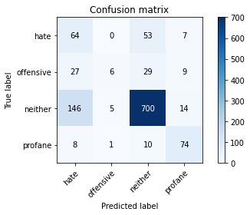

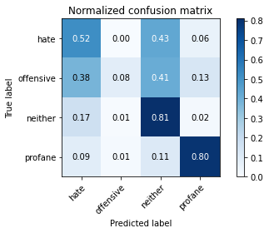

precision recall f1-score support

hate 0.26 0.52 0.35 124

offensive 0.50 0.08 0.14 71

neither 0.88 0.81 0.84 865

profane 0.71 0.80 0.75 93

accuracy 0.73 1153

macro avg 0.59 0.55 0.52 1153

weighted avg 0.78 0.73 0.74 1153

average eval_loss: 0.7103920265518385, accuracy: 0.7320034692107545

training 4 epoch...

140.528404712677 seconds used......

4 training finished! average train loss: 0.4112849476343536

evaluating...

Confusion matrix, without normalization

[[ 36 8 68 12]

[ 16 8 26 21]

[120 10 702 33]

[ 5 2 7 79]]

Normalized confusion matrix

[[0.29032258 0.06451613 0.5483871 0.09677419]

[0.22535211 0.11267606 0.36619718 0.29577465]

[0.13872832 0.01156069 0.81156069 0.03815029]

[0.05376344 0.02150538 0.07526882 0.84946237]]

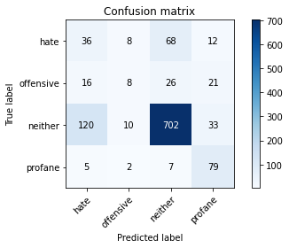

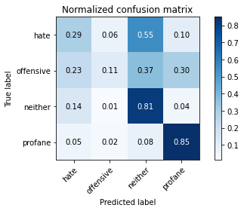

precision recall f1-score support

hate 0.20 0.29 0.24 124

offensive 0.29 0.11 0.16 71

neither 0.87 0.81 0.84 865

profane 0.54 0.85 0.66 93

accuracy 0.72 1153

macro avg 0.48 0.52 0.48 1153

weighted avg 0.74 0.72 0.72 1153

average eval_loss: 0.7987303607936563, accuracy: 0.7155247181266262

training 5 epoch...

140.47193479537964 seconds used......

5 training finished! average train loss: 0.20971080523505553

evaluating...

Confusion matrix, without normalization

[[ 62 1 56 5]

[ 26 7 21 17]

[184 6 655 20]

[ 9 1 8 75]]

Normalized confusion matrix

[[0.5 0.00806452 0.4516129 0.04032258]

[0.36619718 0.09859155 0.29577465 0.23943662]

[0.21271676 0.00693642 0.75722543 0.02312139]

[0.09677419 0.01075269 0.08602151 0.80645161]]

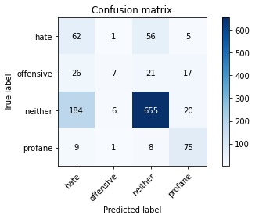

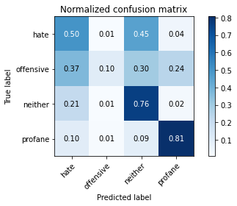

precision recall f1-score support

hate 0.22 0.50 0.31 124

offensive 0.47 0.10 0.16 71

neither 0.89 0.76 0.82 865

profane 0.64 0.81 0.71 93

accuracy 0.69 1153

macro avg 0.55 0.54 0.50 1153

weighted avg 0.77 0.69 0.71 1153

average eval_loss: 1.0098595963469867, accuracy: 0.6929748482220295

2 run......

training 1 epoch...